CS 255 System Design Document Template

This template lays out all the different sections that you need to complete for Project Two. Each section has guidance to prompt your thinking. You will need to continually reference the interview transcript as you work to make sure that you are addressing your client’s needs. There is no required length for the final document. Instead the goal is to complete each section based on what your client’s needs are. Remove this note when you are finished, and replace all bracketed text with the relevant information.

UML Diagrams

UML Use Case Diagram
[In Module Six, you were asked to complete a use case diagram based on your system design. If you would like to make any adjustments to your diagram, please do so. Please insert your use case diagram here. Check to make sure that you included appropriate components and symbols and that your design meets the client’s needs.]
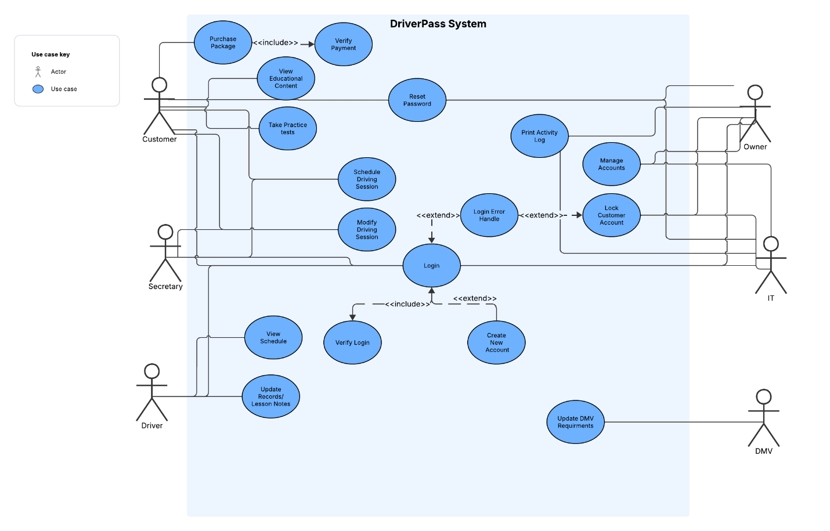

UML Activity Diagrams
[You were asked to choose two use cases and create two activity diagrams, one for each use case. Please insert both of your activity diagrams here. Check to make sure that you included appropriate components and symbols and that your design meets the client’s needs.]
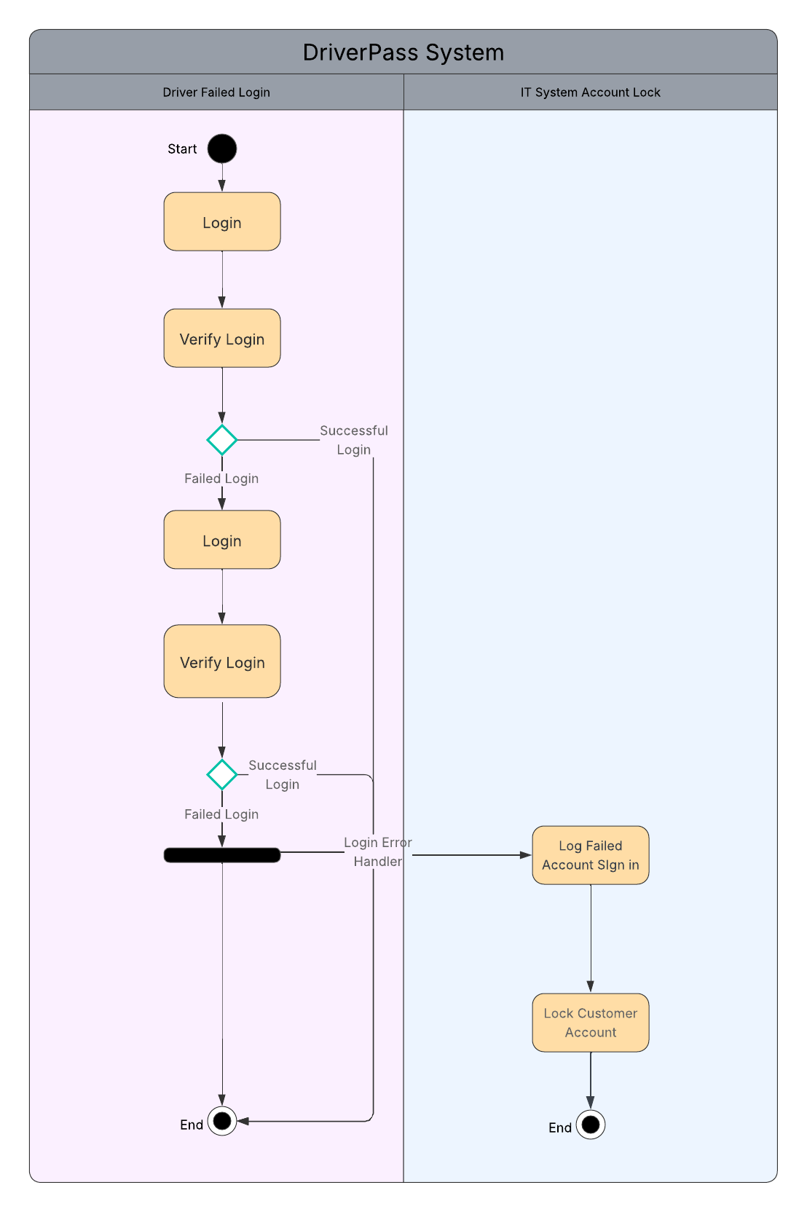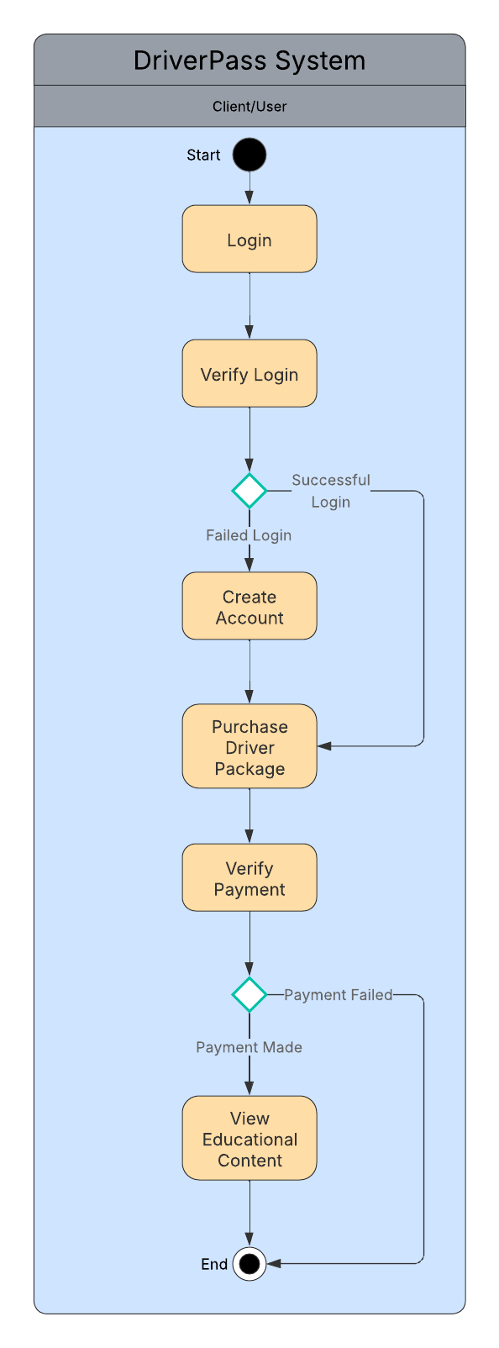

UML Sequence Diagram
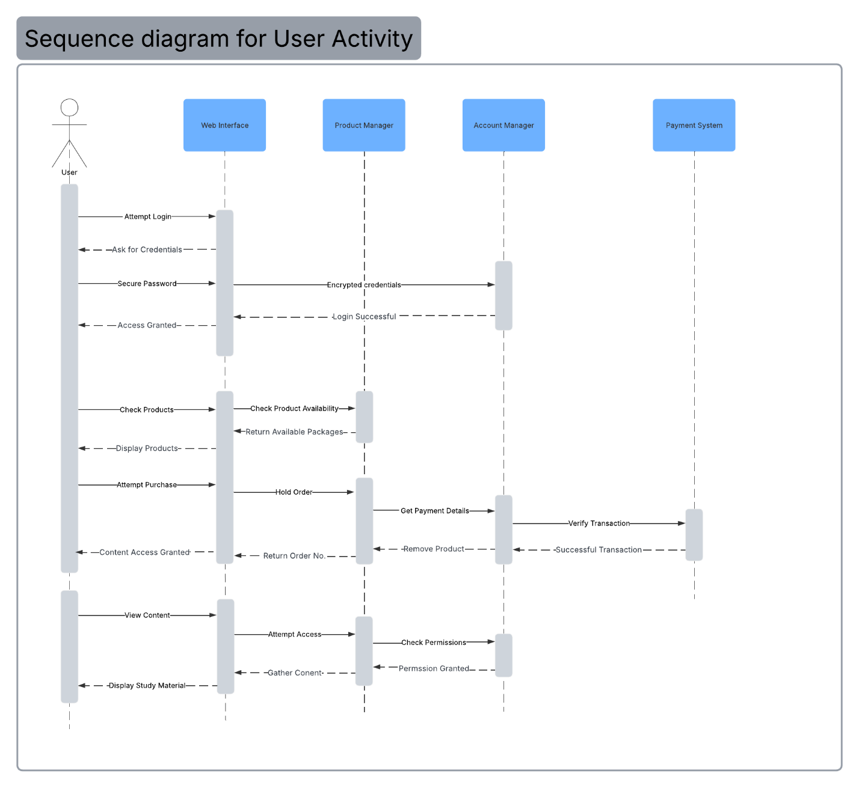

UML Class Diagram
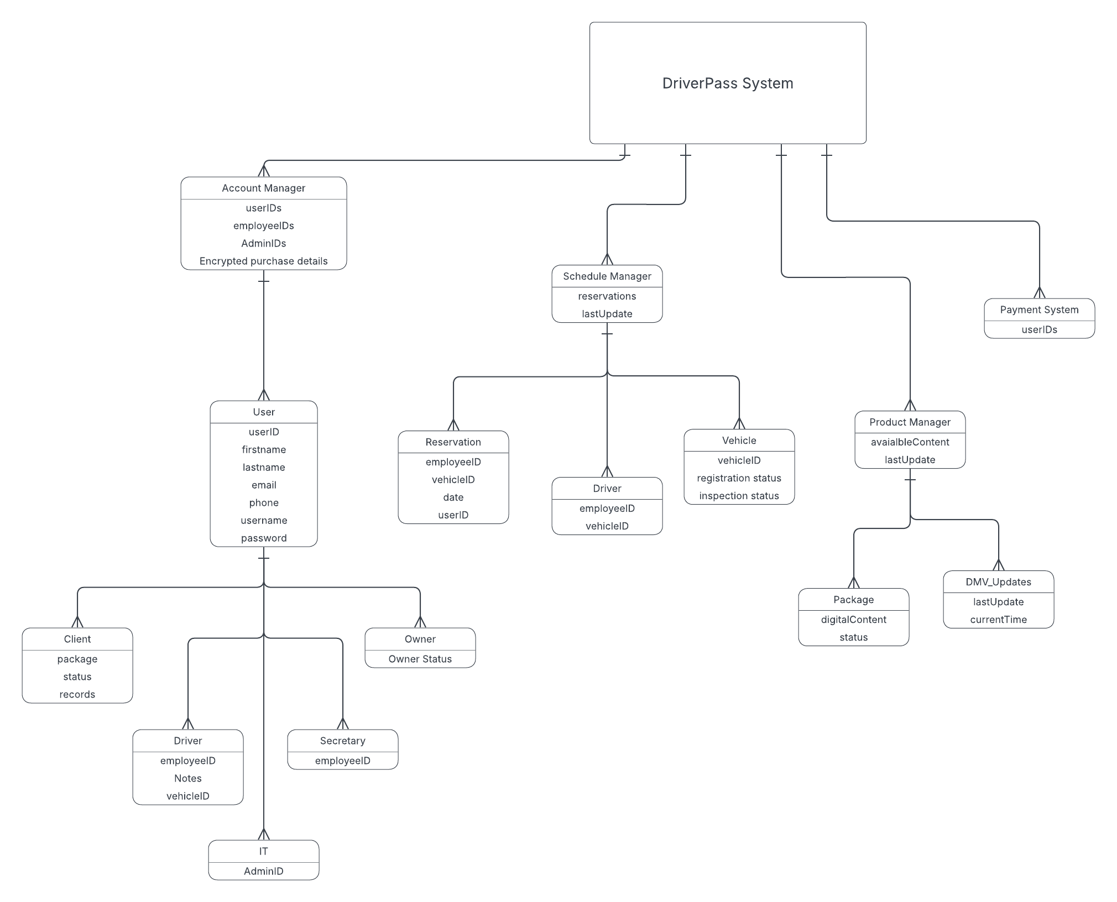

Technical Requirements
The DriverPass system will be a web-based application that requires a web server, database server, and reliable internet connectivity. Customers and employees will access the system through standard web browsers on computers or mobile devices. The system will use a database to store customer information, schedules, educational content, and payment records. Security features include user authentication, account locking after repeated failed login attempts, password recovery, and activity logging. The system will also integrate a third-party payment provider and external DMV information sources to ensure secure transactions and up-to-date educational content. Lastly, the infrastructure must support multiple users simultaneously making reservations of viewing digital educational content.

